**LAB LOCATOR APP SETUP**

1. In your windows computer browse <https://evothings.com/download/> .
2. Scroll down to “Step 2.Get a cloud token” section.

2.1 Click on the checkbox “I agree to Evothings End user Licence Agreement”.

2.2 Click on “Get AP token” button.

2.2 Copy the newly generated AP token.

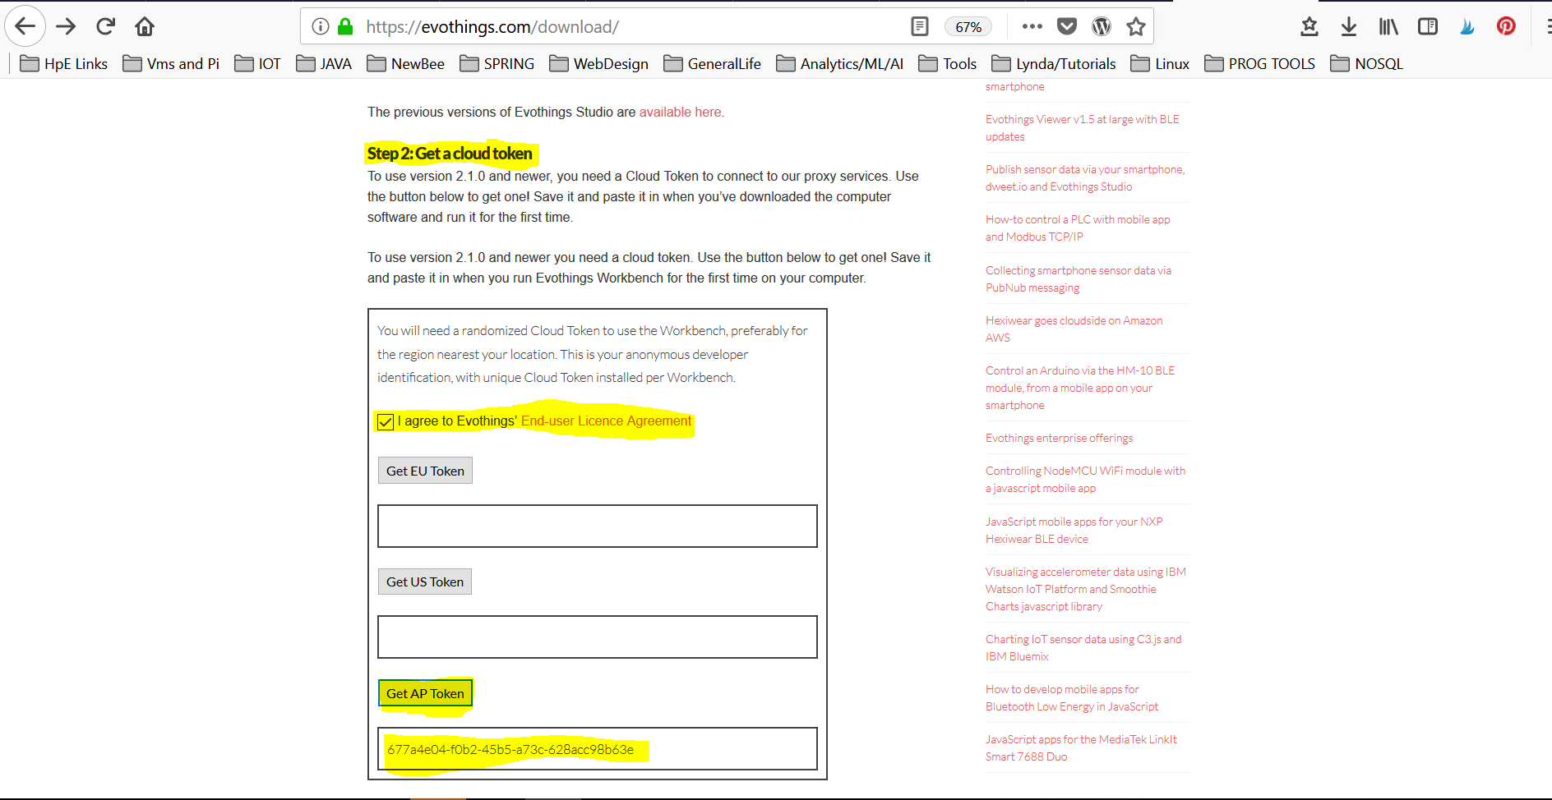

1. Download Evothings studio from this link <https://s3-eu-west-1.amazonaws.com/evothings-download/evothings-studio-2.2.1.exe> .
2. Install Evothings studio
3. Open Evothings studio.

5.1 Click on Connect tab.

5.2 Paste the cloud token in the box mentioned in black and yellow .

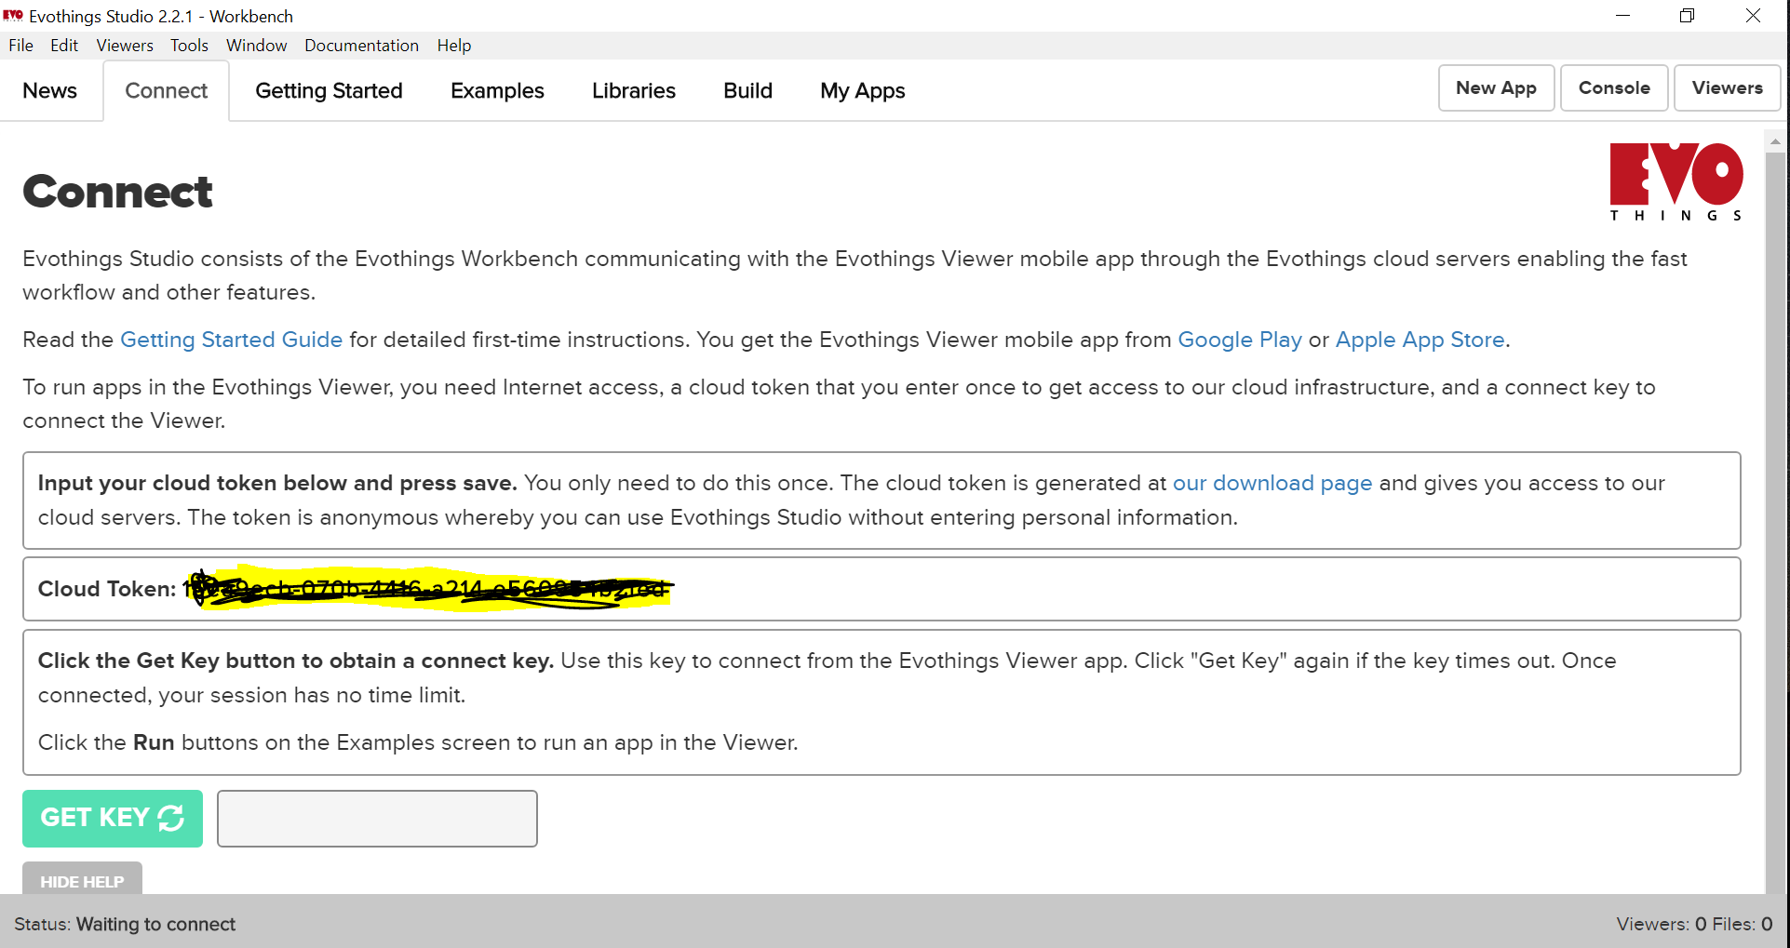

1. Unzip indoorLocator-latest.zip .
   1. Open indoorLocator-latest folder .
   2. Click on the Index.html file . Drag it to Evothing studio window.
   3. You will see in Evothings studio , ‘My app’ tabs the new app is created.

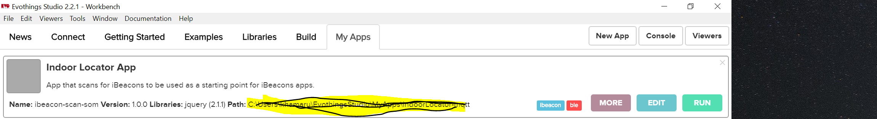

1. Move to connect tab in Evothings studio window.

7.1 Click on ‘GET KEY’ button.

7.2 Copy the key generated from box marked in yellow and black.

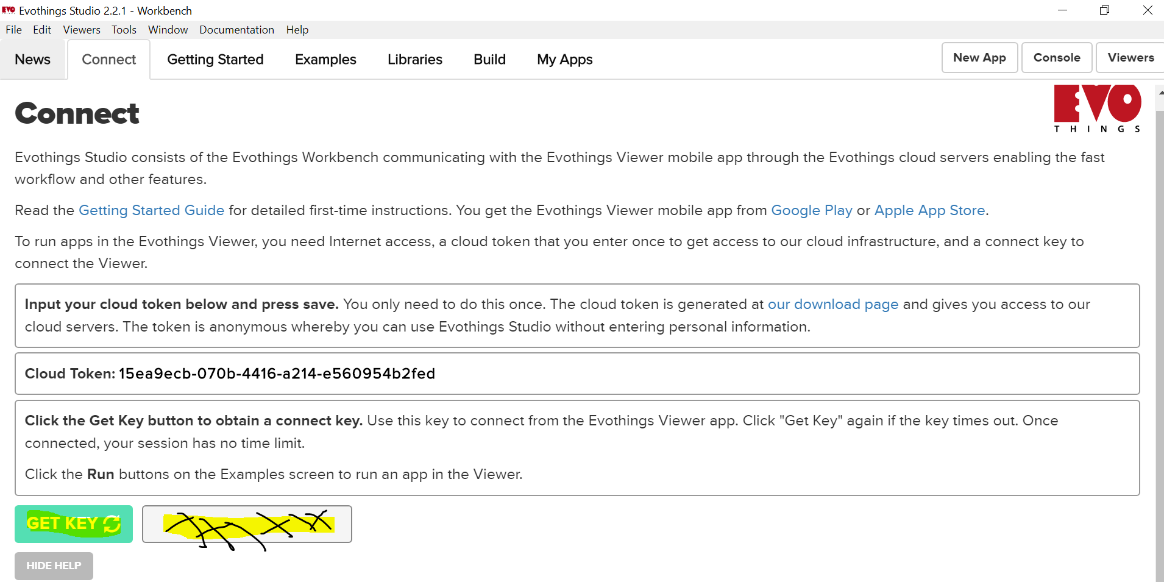

1. In your mobile open playstore and download ‘Evothings Viewer App’ <https://play.google.com/store/apps/details?id=com.evothings.evothingsviewer>
2. Turn on **Bluetooth, location** in your mobile .Open Evothings viewer app

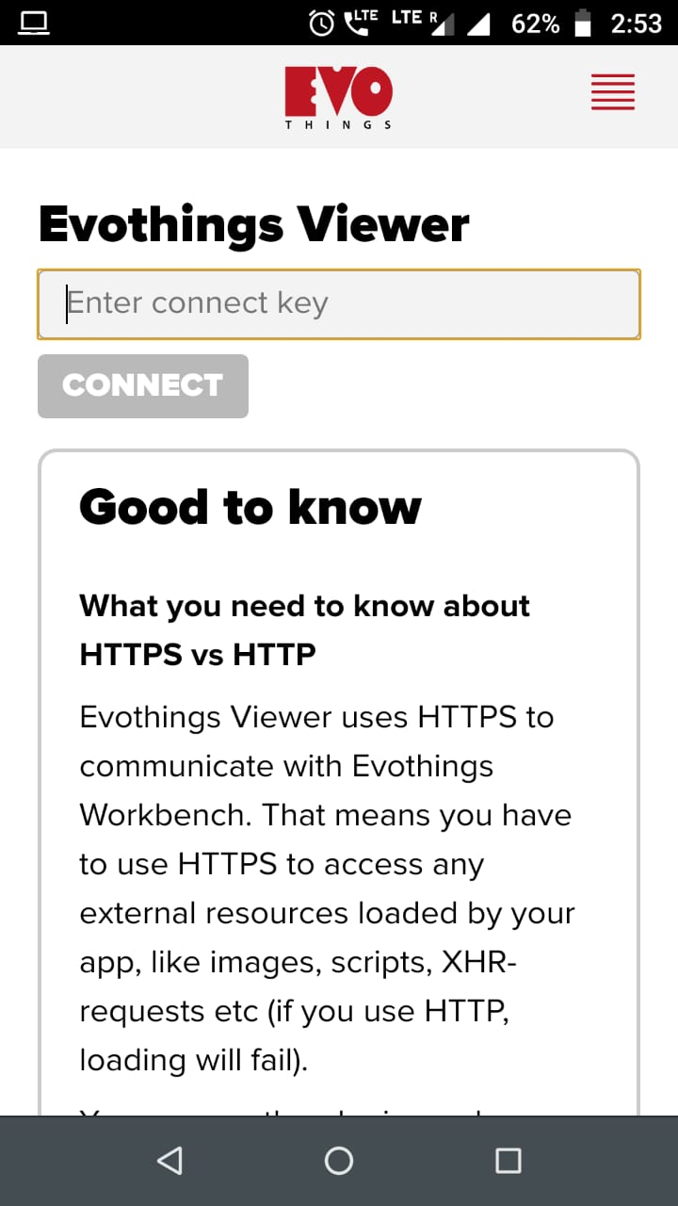

* 1. Enter the connect key and click on connect.
  2. Now in your computer, in the Evothings studio window move to ‘My Apps’ tab. Click on Run button.



* 1. So now the app will be casted in your mobile phone through the Evothings viewer app.

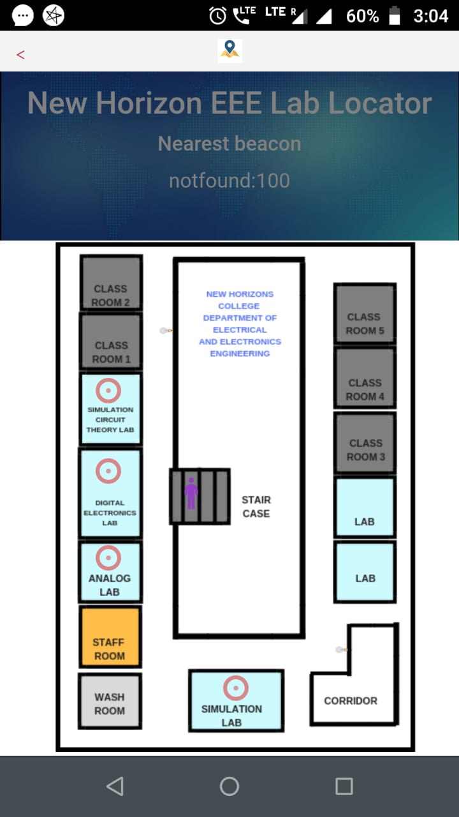

1. Take another mobile download ‘Beacon Simulator App’ from play store.

<https://play.google.com/store/apps/details?id=net.alea.beaconsimulator>

* 1. Install the app.
  2. Open the app

1. Open the ‘Beacon Simulator App’.

We will make four beacon with the following uuid :

* **1a7a4b20-d4e8-4d94-bc09-e79bafa7b5b4**
* **2561e402-bcf8-4337-9edf-92eec36ffeb3**
* **f7826da6-4fa2-4e98-8024-bc5b71e089b2**
* **e20a39f4-73f5-4bc4-a12f-17d1ad07a9b1**
  1. Click on the orange white ‘+’ button.. Then

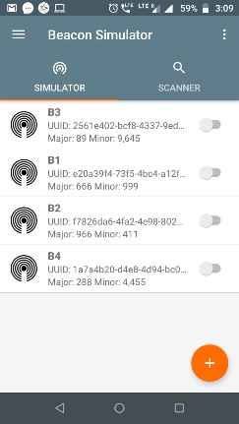

11.2 Then select ‘iBeacon’.

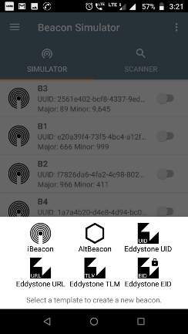

* 1. Then Give name to ibeacon ( the name will be the last two digit of the beacon uuid) . So for **1a7a4b20-d4e8-4d94-bc09-e79bafa7b5b4** uuid the beacon name will be B4.Type the above mentioned uuid in the box. Type the last 4 dight if the uuid as major and first 4 digit as minor.

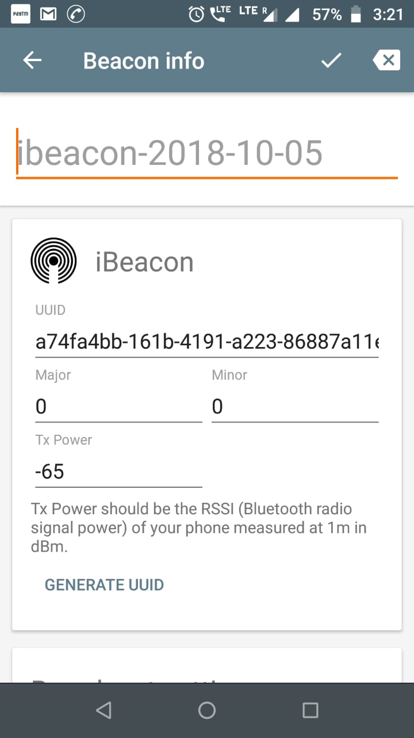

11.3. Scroll the app, under Broadcast settings set the Transmission Power and Frequency Mode as given in the picture. Then click on the tick icon to save.

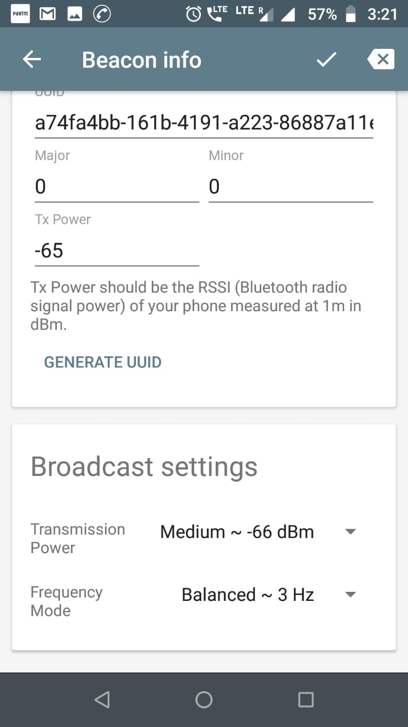

1. Repeat step 11 for all the uuids. So ultimately you will create 4 beacons with name B4, B3, B2,B1

Your app will look like this.

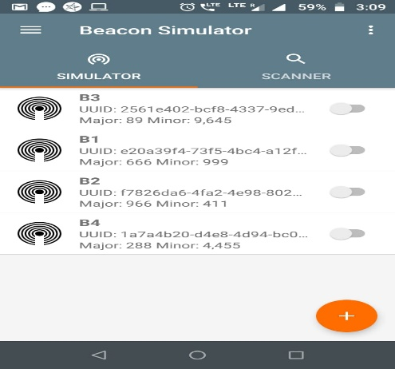

1. Switch on your phone blue tooth and switch on any beacon by pressing on the slider on its side.